INDIANA
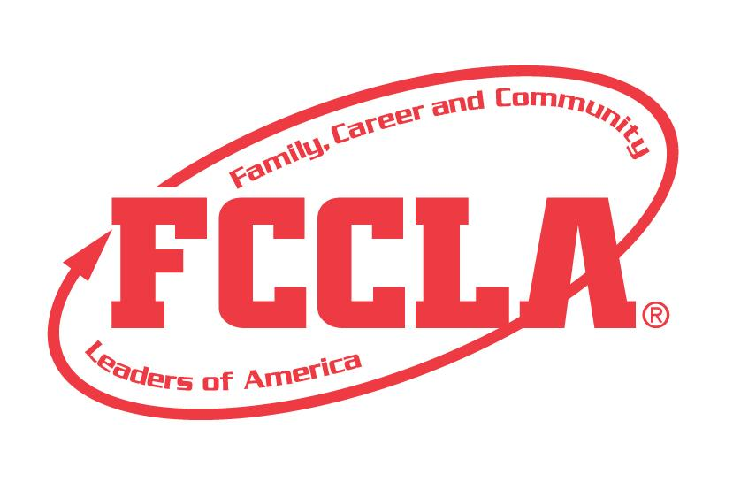

Trend Board
for
Fashion or Interior Design

STATE PROJECT

FCCLA members must be affiliated by February 1st

Trend Board
Fashion or Interior Design

Overview: Trend Board is a project to recognize participants who use the planning process to demonstrate their ability to create a visual layout that gives a comprehensive overview of trends on market behavior for an upcoming season.

Participants must prepare a trend board that could be used by members of the fashion or interior design industry to make a trend-relevant presentation. Trend boards can be presented internally to showcase line or company direction or be presented to buyers to showcase a concept for the upcoming season. Trend boards communicate thoughts on trend direction in color and print design themes.

Participants must prepare a tri-fold display or digital presentation trend board that communicates thoughts on trend direction in a color trend or a print design theme trend. If participants choose to complete a color trend board, they will need to visit the following website to research the current Pantone color of the year trend.

The color of the year for 2022-2023 school year is:

PANTONE 17-3938 Very Peri
https://www.pantone.com/color-of-the-year-2022

If participants choose to complete a print design theme trend, they will need to choose from the list below and complete research on the print design theme.
- Faux texture, optical illusion, plaids, arctic chill, city tour, collision, contrived skins, minute impressions, relaxed geometry, floral

There are two pathways you can choose from for this state project:
- Fashion: Participants will design a two-piece garment for a male and female influenced and inspired by the chosen trend.
- Interior Design: Participants will design two rooms influenced and inspired by the chosen trend.

Entry: Individual or Team (maximum of 3) Event

VISUAL GUIDELINES:
- Use the planning process to develop your project and include the planning process summary.
- For this project a Trifold Board or Digital Presentation can be used.
  - Trifold Board: A tri-fold display board (not exceeding 18” deep X 4’ wide X 4’ high, with no use of electrical equipment).
  - Digital Presentation: Powerpoint or Google Slides Presentation must be submitted with no more than 30 slides total. Name the file with the student first and last name, chapter name, and state project.

PROJECT DETAILS:
Display Board | Slides Presentation
- The title of the project, Beyond the Basics, must be included on the front of the board  - There must be a 3” X 5” index card attached to the lower corner on the back of the display that identifies: Name, Chapter name, School, City, State, Grade and District.  - Each step of the Planning Process is fully explained, neatly typed, no more than 1 page total for the Planning Process. | - The title of the project, Beyond the Basics, must be included (If digital: Title must be on Slide 1).  - A slide identifying: Name, Chapter name, School, City, State, Grade and District.  - Each step of the Planning Process is fully explained, neatly typed, and can be up to five slides total for the Planning Process.

PROJECT DETAILS:
- The presentation must include the following:

- One to three slides/pages should include a collage that gives a comprehensive overview of the chosen color or print design theme.

- Creative title that reflects your trend.

- Evidence of Research on your chosen trend on up to two slides/pages with sources documented.

- Two trend-influenced and inspired designs. The designs can be digital/ computer generated or hand drawn (picture of drawn design) and should be on separate slides/pages.

Fashion:
- Design a two-piece garment for a male and female that is appropriate and covers both the top and bottom half of the body.

Interior Design:
- Design two rooms inspired by the trend.

FCCLA Planning Process
Summary Page Template
(This template may be modified, but all headings must be used in the correct order. The FCCLA logo and
Planning Process graphics are encouraged but not required.)

IDENTIFY CONCERNS

SET A GOAL

FORM A PLAN (WHO, WHAT, WHEN, WHERE, HOW, COST, RESOURCES, AND EVALUATION)

ACT

FOLLOW UP

Fashion and Textile Trend Board
SELF SCORE IS OPTIONAL
Fashion or Interior Design (Circle One) Theme: Color or Print Design (Circle One)
Evaluation |  |  |  | Self-Score | Score
SLIDE PRESENTATION  0 – 10 pts | Does not meet the specifications  Not neat or appealing  More than 2 required elements missing  0-3 | No Title  Missing 1or 2 required elements. Visual appeal could be improved  4-7 | Meets size specification Title included  Neat and well organized and visually appealing  8-10
FCCLA PLANNING PROCESS  0 – 10pts | Not attached  Not legible  0-3 | Available, but not attached  All steps are summarized  Somewhat messy  4-7 | Planning Process is fully explained, neatly typed or written, and attached  8-10
GRAMMAR  0 – 10 pts | Extensive grammatical and spelling errors  0-3 | Few grammatical and spelling errors  4-7 | No grammatical or spelling errors  8-10
APPEARANCE  0 –10 pts | Display has minimal appeal both in design and content  0-3 | Display needs some improvement in design and content  4-7 | Visually appealing,  creative, and appropriate in design and content  8-10
EVIDENCE OF RESEARCH  0 -- 15 pts | No research or very minimal research presented  0-4 | Some research is evident but is lacking or sources are not cited  5-9 | Well-developed research about the trend is shared with cited sources  10-15
COLLAGE  0 --15 pts | Not included or not representative of the theme  0-4 | Collage is included but not representative of the theme  5-9 | Collage represents theme with a creative aesthetic  10-15
DESIGN ONE  0 – 15 pts | Design is incomplete or missing  0-4 | Design is included, somewhat developed  5-9 | Design is included, highlights the trend and utilizes design elements  10-15
DESIGN TWO  0 – 15 pts | Design is incomplete or missing  0-4 | Design is included, somewhat developed  5-9 | Design is included, highlights the trend and utilizes design elements  10-15
TOTAL: 100 PTS POSSIBLE
Comments:

Name__________________________________________School___________________________________
0-69 | 70-79 | 80-89 | 90-100
Participation | Bronze | Silver | Gold

