INDIANA

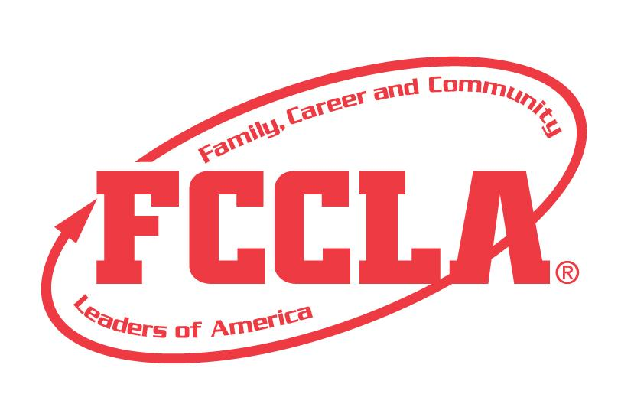

S. M. I. L. E.

Sharing Moments In the Lives of the Elderly

STATE PROJECT

FCCLA members must be affiliated by February 1st

S.M.I.L.E.

Overview: S.M.I.L.E. (Sharing Moments In the Lives of the Elderly) is a project recognizing chapters who use the planning process to team with the elderly in their community to strengthen an understanding of each other. Students must create a presentation demonstrating their increased knowledge of the elderly and the public awareness of the chapter’s community involvement. This is a chapter project.

Entry: Individual or Team (maximum of 3) event to represent the chapter project

VISUAL GUIDELINES:
- Use of the planning process to develop your project and include the planning process summary.
- For this project a Trifold Board or Digital Presentation can be used.
  - Trifold Board: A tri-fold display board (not exceeding 18” deep X 4’ wide X 4’ high, with no use of electrical equipment).
  - Digital Presentation: PowerPoint or Google Slides presentation must be submitted with no more than 30 slides total. Name the file with the student first and last name, chapter name, and name of the state project.

PROJECT DETAILS:
Display Board | Slides Presentation
- The title of the project, SMILE, must be included on the front of the board  - There must be a 3” X 5” index card attached to the lower corner on the back of the display that identifies: Name, Chapter name, School, City, State, Grade & District.  - Each step of the Planning Process is fully explained, neatly typed, no more than 1 page total for the Planning Process. | - The title of the project, SMILE, must be included (If digital: Title must be on Slide 1).  - A slide identifying: Name, Chapter name, School, City, State, Grade and District.  - Each step of the Planning Process is fully explained, neatly typed, and can be up to five slides total for the Planning Process.

- The presentation must include explanations and evidence of the following:
  - brought elderly awareness to the community by . . .
  - benefited the community by . . .
  - benefited the FCCLA chapter by . . .
Some items that may be used to show community awareness, but not limited to:
  - Newspaper Clippings (utilized pictures as needed)
  - Project Samples
  - Pictures
  - Social Media
- The project will be evaluated according to the S.M.I.L.E. rubric

FCCLA Planning Process
Summary Page Template
(This template may be modified, but all headings must be used in the correct order. The FCCLA logo and Planning Process graphics are encouraged but not required.)

IDENTIFY CONCERNS

SET A GOAL

FORM A PLAN (WHO, WHAT, WHEN, WHERE, HOW, COST, RESOURCES, AND EVALUATION)

ACT

FOLLOW UP

S.M.I.L.E.

Self Score is Optional

Evaluation |  |  |  | Self-Score | Score
DISPLAY OR SLIDE PRESENTATION  0 – 10 pts | Not neat or appealing. More than 2 required elements missing  0-3 | No Title  Missing 1 or 2 required elements. Visual appeal could be improved  4-7 | Title included  Neat and well organized and visually appealing  8-10
FCCLA PLANNING PROCESS  0 – 15 pts | Not attached  Not legible  0-4 | Available, but not attached  All steps are summarized  Somewhat messy  5-9 | Planning Process is fully explained, neatly typed or written, and attached  10-15
GRAMMAR  0 – 10 pts | Extensive grammatical and spelling errors  0-3 | Few grammatical and spelling errors  4-7 | No grammatical or spelling errors  8-10
APPEARANCE  0 – 15 pts | Display has minimal appeal both in design and content  0-4 | Display needs some improvement in design and content  5-9 | Visually appealing,  creative, and appropriate in design and content  10-15
PROJECT ID INDEX CARD  0 – 5 pts | Missing 2 or more ID elements or not provided  0-1 | Missing 1 ID element,  ID index card misplaced  2-3 | All ID elements on index card on board  4-5
COMMUNITY  ELDERLY  AWARENESS  0 – 15 pts | Explanation or evidence missing or limited  0-4 | Explanation or evidence basic, not detailed  5-9 | Community elderly awareness evident and thorough multiple sources  10-15
BENEFITED THE COMMUNITY  0 – 15 pts | Explanation or evidence missing or limited  0-4 | Explanation or evidence basic, not detailed  5-9 | Benefits to the elderly community clear and thorough  10-15
BENEFITED THE FCCLA CHAPTER  0 – 15 pts | Explanation or evidence missing or limited  0-4 | Explanation or evidence basic, not detailed  5-9 | Benefits to the chapter clear and thorough  10-15
Total 100 pts possible

COMMENTS:

Name_________________________________________School__________________________________
0-69 | 70-79 | 80-89 | 90-100
Participation | Bronze | Silver | Gold

