TIME | ACTIVITY

Sunday, March 5, 2023
3:00 pm – 8:30 pm | FCCLA Conference Registration
3:00 pm – 4:00 pm | Orientation for New Advisers
4:00 pm – 9:00 pm | STAR Event Information
5:30 pm – 6:00 pm | State Project Check-In
4:00 pm | Orientation for LC & STAR Event Evaluators
4:30 pm | Specific Orientation for STAR Event Participants
4:45 pm – 8:30 pm | STAR EVENTS
Chapter in Review Display/Portfolio
Chapter Service Project Display/Portfolio
Entrepreneurship
Event Management
Fashion Design
Food Innovations
Interior Design
Job Interview
Leadership
National Programs in Action
Public Policy Advocate
Sustainability Challenge
Teach or Train

9:00 – 10:30 pm | Opening General Session

Monday, March 6, 2023
7:00 am – 6:00 pm | FCCLA Conference Registration  (STAR Event Information)
7:30 am – 8:30 am | Group Exercise Time
8:00 am – 3:00 pm | ProStart FCCLA Invitational  ProStart Management  Baking and Pastry Competition
8:00 am | Orientation for LC & STAR Event Evaluators
8:30 am | Specific Orientation for STAR Event Participants
 | STAR EVENTS Morning Session
8:45 am- 12:00 pm | Career Investigation  Fashion Construction  Nutrition and Wellness  Professional Presentation  Repurpose and Redesign  Sports Nutrition
9:00 am – 3:00 pm | Prize Wheel
9:00 am – 3:00 pm | Exhibits
9:00 am – 10:00 am | State Project Check-In
9:00 am – 9:45 am | State Officer Candidate Speeches
10:00 am – 11:15 am | State Officer Candidates Round Robin
9:00 am – 11:45 am | Youth Sessions
12:30 pm | Orientation for LC & STAR Event Evaluators
1:00 pm | Specific Orientation for STAR Event Participants
1:15 pm – 3:00 pm | STAR EVENTS Afternoon Session
Culinary Math Management*case study
Focus on Children
Early Childhood*
Hospitality, Tourism and Rec.*
Interpersonal Communications*
Parliamentary Procedure*
Promote and Publicize*

1:30 pm – 2:30 pm | Youth Sessions
3:00 pm – 4:30 pm | Second General Session
4:30 pm – 5:15 pm | District Meeting Time
6:45 pm | State Project Line Up
7:00 pm – 9:00 pm | Third General Session/Business Meeting
9:30 pm – 10:30 pm | Adviser Reception and Awards
9:30pm – 11:00 pm | Dance

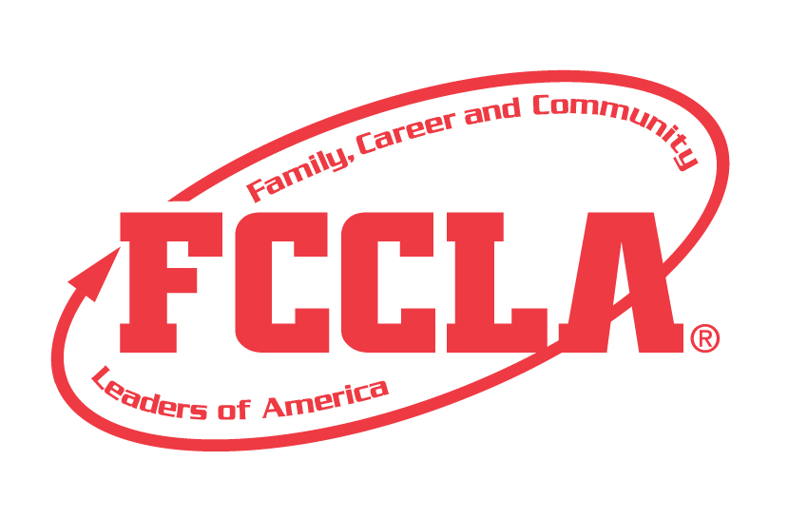

Tuesday, March 8, 2023
9:00 am | Check out of Hotel
9:30 am | STAR Event Line-up
10:00 am – 12:00 PM | Closing General Session

