TIME | ACTIVITY

Sunday, March 6, 2022
3:00 pm – 8:30 pm | FCCLA Conference Registration
3:00 pm – 4:00 pm | Orientation for New Advisers
4:00 pm – 9:00 pm | STAR Event Information
5:30 pm – 6:00 pm | State Project Check-In
4:15 pm | Orientation for LC & STAR Event Evaluators
4:40 pm | Specific Orientation for STAR Event Participants
5:00 pm – 8:30 pm | STAR EVENTS
Chapter in Review
Chapter Service
Early Childhood
Entrepreneurship
Fashion Design
Food Innovations
Interior Design
Interpersonal Communications
Job Interview
Leadership
National Programs in Action
Parliamentary Procedure
Promote and Publicize
Public Policy Advocacy
9:00 – 10:30 pm | Opening General Session

Monday, March 7, 2022
7:00 am – 6:00 pm | FCCLA Conference Registration  (STAR Event Information)
7:30 am – 8:30 am | Group Exercise Time
8:00 am – 3:00 pm | ProStart FCCLA Invitational  ProStart Management  Baking and Pastry Competition
8:15 am – 8:45 am | Orientation for LC & STAR Event Evaluators
8:45 am – 9:00 am | Specific Orientation for STAR Event Participants
 | STAR EVENTS Morning Session
9:00 am- 3:00 pm | Career Investigation  Culinary Math Management  Event Management  Fashion Construction  Focus on Children  Hosp., Tourism, and Rec  Nutrition and Wellness  Professional Presentation  Repurpose and Redesign  Say Yes to FCS  Sports Nutrition  Sustainability Challenge  Teach and Train
9:00 am – 3:00 pm | Prize Wheel
9:00 am – 3:00 pm | Exhibits
9:00 am – 10:00 am | State Project Check-In
9:00 am – 9:45 am | State Officer Candidate Speeches
10:00 am – 11:15 am | State Officer Candidates Round Robin
9:00 am – 11:45 am | Youth Sessions
12:30 pm – 3:00 pm | STAR EVENTS Afternoon Session
1:30 pm – 2:30 pm | Youth Sessions
3:00 pm – 4:30 pm | Second General Session
6:45 pm | State Project Line Up
7:00 pm – 9:00 pm | Third General Session/Business Meeting
9:30 pm – 10:30 pm | Adviser Reception and Awards
9:30pm – 11:00 pm | Dance

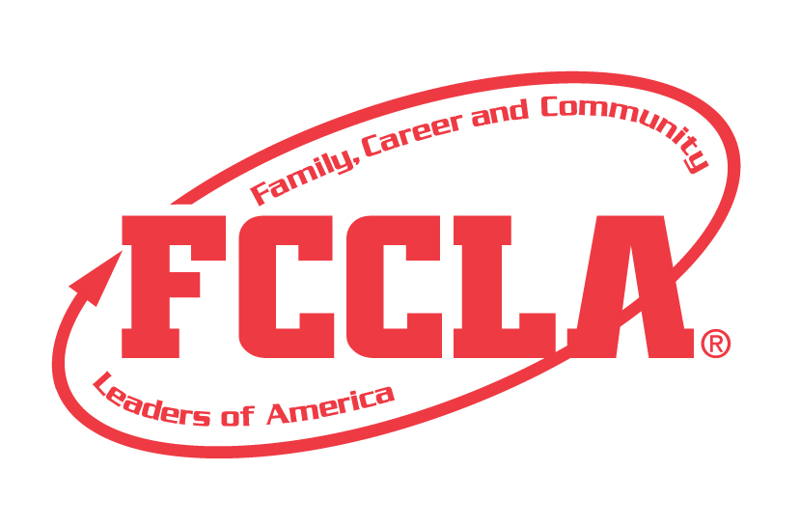

Tuesday, March 8, 2022
9:00 am | Check out of Hotel
9:30 am | STAR Event Line-up
10:00 am – 12:00 PM | Closing General Session

