INDIANA

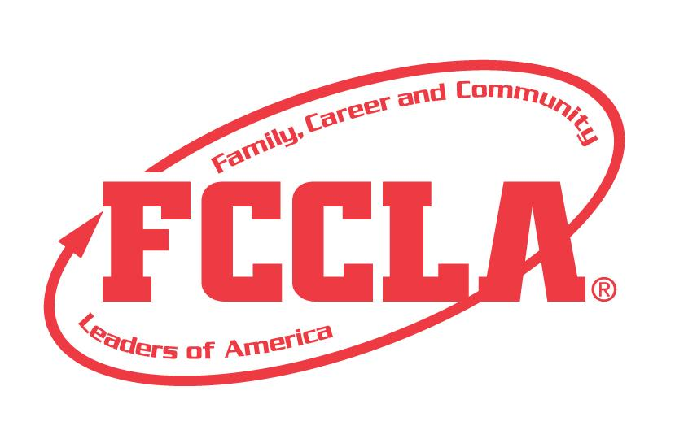

RECRUIT

Special Project for the Education Cluster

(Early Childhood Education and Education Professions)

STATE PROJECT

FCCLA members must be affiliated by February 1st

Recruit

Overview: Recruit is an Indiana state project recognizing student teams who use the planning process to encourage more students to be more involved in Family and Consumer Sciences Education pathways. The project can focus on Early Childhood Education or Education Professions or both. Participants must create a three ring binder or electronic portfolio and project planning summary page demonstrating their marketing plan and recruitment activities.

Entry: Individual or Team (maximum of 3) Event

PORTFOLIO GUIDELINES:
- For this project a PDF file can be submitted electronically OR a Three Ring Binder can be used.
  - Three Ring Binder: this can be in the official FCCLA red or white three ring binder (can be purchased through the E-Store)
  - PDF File: For submission, please submit portfolio as one pdf file. Name the file with the student first and last name, chapter name, and name of the state project.

- A title or title page must be on the front of the portfolio. The title of the project, Career Exploration must be included. A subtitle is optional.
- There must be a project identification page (8 ½” X 11”) page in the portfolio identifying:
  - Participant name
  - Participant grade
  - Name of chapter
  - Name of school, school address, city and state
  - District number
- Includes planning process summary page up to 2 pages
- Up to 20 pages TOTAL

PROJECT DETAILS:
- Each step of the Planning Process is fully explained, neatly typed or written and placed in the portfolio.
- The portfolio must include explanations and evidence of the following:
- A promotion plan: A planned, cohesive promotion and publicity campaign. Specify current year plans and a timetable for implementation. Examples of promotion efforts include: a recruitment packet, website, bulletins, online and paper brochures, letters to potential pathway enrollees, school officials, and community members, handouts for FCS classes and FCCLA chapter events, and public relations activities aimed at other professional organizations.
- Evidence of Campaign: Publicity about recruitment events and initiatives appropriate promotional materials, e.g. news articles
- Evidence of Technology Used: Use technology to develop promotional materials that raise awareness about career opportunities in education pathways and to educate the school, parents, and members of the community. Examples of technology include, but are not limited to: social media, computer applications, audio or video production, multimedia, slides, and photography. Hard copies/pictures must be included in portfolio.
  - Show results: Ideally, the results should be measurable, such as an increase in students interested an education pathway, increase in student enrollment in one of the courses or pathways, increase in chapter membership from previous school year (can be seen on chapter affiliation), etc.
- The project will be evaluated according to the rubric.

FCCLA Planning Process
Summary Page Template
(This template may be modified, but all headings must be used in the correct order.
The FCCLA logo and Planning Process graphics are encouraged but not required.)

IDENTIFY CONCERNS

SET A GOAL

FORM A PLAN (WHO, WHAT, WHEN, WHERE, HOW, COST, RESOURCES, AND EVALUATION)

ACT

FOLLOW UP

Recruit

Self Scoring is Optional
Evaluation |  |  |  | Self-Score | Score
PORTFOLIO  0-5 pts | Does not meet size specification and missing title and project ID page  0-1 | Does not meet size specification or missing required elements  2-3 | Meets size specification, title and project ID page included  Neat and well organized  4-5
FCCLA PLANNING PROCESS  0 – 15 pts | Not included or not well developed  0-4 | Included but not complete  5-9 | Planning Process is fully explained, neatly typed or written, and included  10-15
GRAMMAR  0 – 10 pts | Extensive grammatical and spelling errors  0-3 | Few grammatical and spelling errors  4-7 | No grammatical or spelling errors  8-10
APPEARANCE  0 – 10 pts | Portfolio has minimal appeal both in design and content  0-3 | Portfolio needs some improvement in design and content  4-7 | Visually appealing,  creative, and appropriate in design and content  8-10
RECRUITMENT PROMOTION PLAN  0 – 15 pts | Promotion plan missing or limited  0-4 | Promotion plan basic, not detailed  5-9 | Promotion Plan is thorough, well-developed, and creative  10-15
EVIDENCE OF CAMPAIGN  0 – 20 pts | Explanation or evidence missing or limited  0-8 | Explanation or evidence basic, not detailed  9-14 | Explanation or evidence is clear and well-defined  15-20
EVIDENCE OF TECHNOLOGY USED  0 – 15 pts | Explanation or evidence missing or limited  0-4 | Explanation or evidence basic, not detailed  5-9 | Explanation or evidence is included and detailed  10-15
RESULTS  0 – 10 pts | Explanation or evidence missing or limited  0-3 | Explanation or evidence basic, not detailed  4-7 | Explanation and evidence of increased public awareness is clear and thorough  8-10
Total 100 pts possible

COMMENTS:

Name_______________________________________School_________________________________

0-69 | 70-79 | 80-89 | 90-100
Participation | Bronze | Silver | Gold

