INDIANA
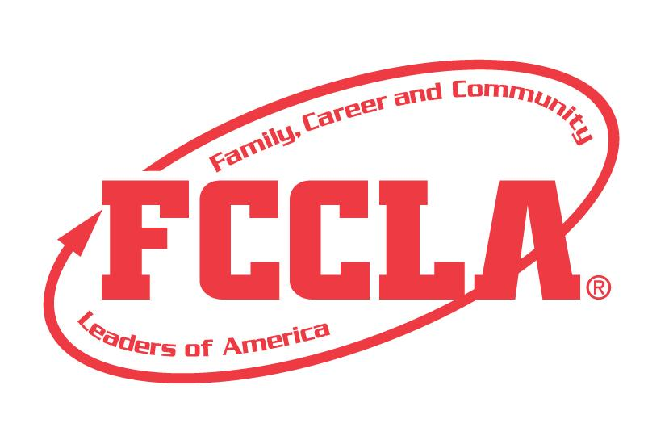
Lesson Planning

STATE PROJECT
FCCLA members must be affiliated by February 1st

Lesson Planning

Overview: Lesson Planning is a project to recognize students who use the planning process to plan an educational lesson for a class. Students will choose a grade level and subject/topic to align utilize in their lesson plan. Students must create a portfolio demonstrating their increased knowledge of Lesson Planning that will be submitted for the State Leadership Conference.

Entry: Individual

PORTFOLIO GUIDELINES:
- For this project a PDF file can be submitted electronically OR a Three Ring Binder can be used.
  - Three Ring Binder: this can be in the official FCCLA red or white three ring binder (can be purchased through the E-Store)
  - PDF File: For submission, please submit portfolio as one pdf file. Name the file with the student first and last name, chapter name, and name of state project.
- A title or title page must be on the front of the portfolio. The title of the project, Lesson Planning must be included. A subtitle is optional.
- There must be a project identification page (8 ½” X 11”) page in the portfolio identifying:
  - Participant name
  - Participant grade
  - Name of chapter
  - Name of school, school address, city and state
  - District number
- Includes planning process summary page up to 2 pages
- Up to 30 pages TOTAL

PROJECT DETAILS:
- Each step of the Planning Process is fully explained, neatly typed, and can be up to five slides total for the Planning Process.
- The Portfolio must include the following, each letter can be a page:
- Grade level
- Subject/Topic
- Indiana State Standards/ Competencies
- State Standards can be found at https://www.in.gov/doe/students/indiana-academic-standards/
- Some CTE (Career and Technical Education) courses standards have been changed to NLPS competencies, and can be found here: (Find course titles on page 3 & 4) https://www.in.gov/gwc/cte/files/NLPS-Review-Doc_Phase2_4.29.22.pdf
- Three SMART learning objectives.
  - Utilize the depth of knowledge sheet to assist in developing learning objectives
- Lesson Plan Page (template attached in packet) including: Grade Level, Subject, Topic, Objectives and State Standards. Also include:
- Opening or Bellringer,
- Introduction to Lesson,
- Lesson,
- Conclusion,
- Resources
- One created material or example that will be used in the lesson.
  - Examples: learning guide, graphic organizer, manipulatives, games, etc
- The project can be up to 30 pages total.
- The project will be evaluated according to the Lesson Planning rubric.
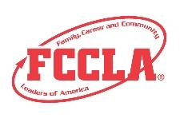
FCCLA Planning Process
Summary Page Template
(This template may be modified, but all headings must be used in the correct order. The FCCLA logo and
Planning Process graphics are encouraged but not required.)

IDENTIFY CONCERNS

SET A GOAL

FORM A PLAN (WHO, WHAT, WHEN, WHERE, HOW, COST, RESOURCES, AND EVALUATION)

ACT

FOLLOW UP

Writing an objective:

- Identify the Level of Knowledge necessary to achieve your objective from the Depth of Knowledge chart below.
- Before you begin writing objectives, stop and think about what you want your students to be able to do at the end of the lesson.
- Select an Action Verb from the chart below that will explain what your students will learn or be able to do at the end of the lesson.
- Create your very own Objective.
Example: Students will be able to analyze a recipe for fat and sugar content.

Depth of Knowledge
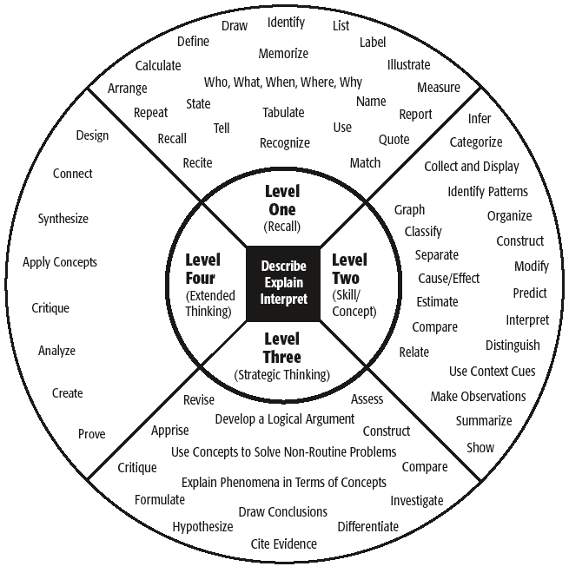
State Standards can be found at
https://www.in.gov/doe/students/indiana-academic-standard

Lesson Plan Template

Grade Level
Subject/Topic
State Standards
Objectives: Students will be able to…
Opening Assignment/Bell Ringer | Time:
Introduction | Time:
Main Lesson | Time:
Conclusion | Time:
Resources Used

Lesson Planning Self-Score is Optional
EVALUATION |  |  |  | Self-Score | Score
PORTFOLIO  0 – 10 pts | Does not meet the specifications. Not neat or appealing. More than 2 required elements missing  0-3 | No Title  Missing 1or 2 required elements. Visual appeal could be improved  4-7 | Meets size specification, Title included  Neat and well organized and visually appealing  8-10
FCCLA PLANNING PROCESS  0 – 10pts | Not attached  Not legible  0-3 | Available, but not attached  All steps are summarized  Somewhat messy  4-7 | Planning Process is fully explained, neatly typed or and included  8-10
GRAMMAR  0 – 10 pts | Extensive grammatical and spelling errors  0-3 | Few grammatical and spelling errors  4-7 | No grammatical or spelling errors  8-10
APPEARANCE  0 –10 pts | Presentation has minimal appeal both in design and content  0-3 | Presentation needs some improvement in design and content  4-7 | Visually appealing,  creative, and appropriate in design and content  8-10
PROJECT ID SLIDE  0 – 5 pts | Missing 2 or more ID elements or not provided  0-1 | Missing 1 ID element,  ID index card misplaced  2-3 | All ID elements on index card on board  4-5
GRADE LEVEL AND SUBJECT IDENTIFIED  0-5 pts | No Grade Level Listed  0-1 | Grade Level or Subject Listed  2-3 | Grade Level and Subject Listed  4-5
TOPIC IS RELEVANT FOR GRADE LEVEL  0 – 5 pts | Topic is not relevant or not age appropriate for grade level chosen  0-1 | Topic is somewhat relevant to the grade level chosen  2-3 | Topic is relevant to grade level chosen  4-5
STANDARDS  LISTED AND APPROPRIATE  0 – 5 pts | State Standards are missing or not aligned to lesson  0-1 | State Standards are listed and mostly aligned.  2-3 | State Standards clearly relate to lesson topic  4-5
OBJECTIVES  0-10 pts | Objectives are missing and/or do not explain what students will learn or be able to do.  0-3 | Objective are written, but do not clearly explain what students will learn or be able to do  4-7 | Three objectives are clearly written and easy to understand what students will learn or be able to do  8-10
CREATED MATERIALS  0-10 pts | Materials missing or has no relevance to the lesson  0-3 | Materials created went with the lesson but did not help to reinforce the lesson  4-7 | Materials are relevant to lesson and reinforce lesson  8-10
CREATIVITY  0-5 pts | Lesson lacks creativity and engagement  0-1 | Lesson utilizes some creativity but could be expanded  2-3 | Lesson is creative and engaging  4-5
OVERALL FLOW OF LESSON  0-10 pts | Lesson timing and organization of activities is not appropriate  0-3 | Lesson is logical but timing could be improved  4-7 | Lesson is well-organized and activities are appropriately placed  8-10
TOTAL 100 pts possible (comments on back)

Name__________________________________________School___________________________________

0-69 | 70-79 | 80-89 | 90-100
Participation | Bronze | Silver | Gold

