INDIANA
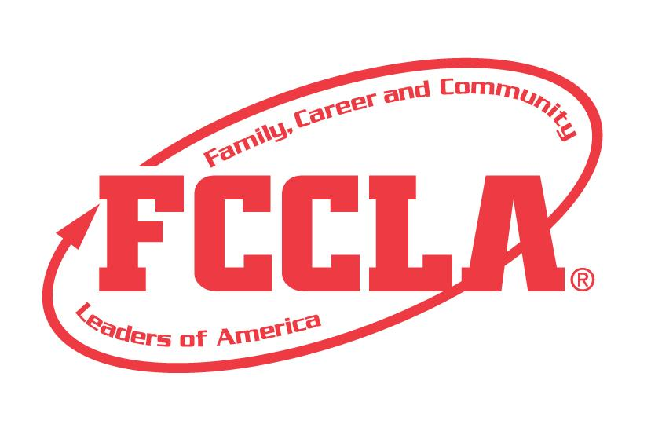

Food Marketing

STATE PROJECT
FCCLA members must be affiliated by February 1st

Food Marketing

Overview: Food Marketing is a project to recognize participants who use the planning process to demonstrate their ability to create a visual layout that gives a comprehensive overview for an innovative food product. Participants must prepare a presentation that highlights important skills found in marketing of food related products. Marketing vision boards can be presented internally to showcase company direction or be presented to buyers to showcase a concept. The marketing approach communicates thoughts on product direction and approach to product success.

Entry: Individual or Team (maximum of 3) Event

VISUAL GUIDELINES:
- Use the planning process to develop your project and include the planning process summary.
- For this project a Trifold Board or Digital Presentation can be used.
  - Trifold Board: A tri-fold display board (not exceeding 18” deep X 4’ wide X 4’ high, with no use of electrical equipment).
  - Digital Presentation: PowerPoint or Google Slides presentation must be submitted with no more than 30 slides total. Name the file with the student first and last name, chapter name, and state project.

PROJECT DETAILS:
Display Board | Slides Presentation
- The title of the project, Food Marketing, must be included on the front of the board  - There must be a 3” X 5” index card attached to the lower corner on the back of the display that identifies: Name, Chapter name, School, City, State, Grade and District.  - Each step of the Planning Process is fully explained, neatly typed, no more than 1 page total for the Planning Process. Include on board. | - The title of the project, Food Marketing, must be included (If digital: Title must be on Slide 1).  - A slide identifying: Name, Chapter name, School, City, State, Grade and District.  - Each step of the Planning Process is fully explained, neatly typed, and can be up to five slides total for the Planning Process.

- The display must include the following:
  - Marketing Plan: Create a marketing plan composed of the elements listed in the attached marketing plan form. Provide information about the product and activities related to promotion of the product. Marketing plan can be up to four slides or 2 pages on board. Cite all sources used to help complete the plan.
  - Food Styling Photo: A food styling photo of the product being utilized for marketing purposes.
  - Social Media Posts: Create at least two social media post examples marketing the product. Up to four social media post examples are allowed and can be up to four slides.
  - Marketing Outreach: One example of a marketing outreach, event, or promotion that goes beyond the social media posts must be included.
FCCLA Planning Process
Summary Page Template
(This template may be modified, but all headings must be used in the correct order. The FCCLA logo and Planning Process graphics are encouraged but not required.)

IDENTIFY CONCERNS

SET A GOAL

FORM A PLAN (WHO, WHAT, WHEN, WHERE, HOW, COST, RESOURCES, AND EVALUATION)

ACT

FOLLOW UP

Food Marketing
SELF SCORE IS OPTIONAL

EVALUATION |  |  |  | Sefl-Score | Score
DISPLAY OR SLIDE PRESENTATION  0 – 10 pts | Not neat or appealing. More than 2 required elements missing  0-3 | No Title  Missing 1 or 2 required elements. Visual appeal could be improved  4-7 | Title included  Neat and well organized and visually appealing  8-10
FCCLA PLANNING PROCESS  0 – 10pts | Not included or complete  Not legible  0-3 | Available, but not included.  All steps are summarized  Somewhat messy  4-7 | Planning Process is fully explained, neatly typed, and included.  8-10
GRAMMAR  0 – 10 pts | Extensive grammatical and spelling errors  0-3 | Few grammatical and spelling errors  4-7 | No grammatical or spelling errors  8-10
APPEARANCE  0 –10 pts | Display has minimal appeal both in design and content  0-3 | Display needs some improvement in design and content  4-7 | Visually appealing, creative, and appropriate in design and content  8-10
MARKETING PLAN  0 -- 20 pts | No research or very minimal research presented  0 – 6 | Some research is evident but is lacking or sources are not cited.  7 – 13 | Well-developed research about the trend is shared with cited sources  14 – 20
FOOD STYLING PHOTO  0 --15 pts | Not included or not representative of the theme  0-4 | Photo is included but not representative of the theme or product  5-9 | Photo represents theme with a creative aesthetic  10-15
SOCIAL MEDIA POSTS  0 – 15 pts | Social Media Post examples are incomplete or missing  0-4 | Some posts are included but not well developed  5-9 | Two-Four Social Media Posts are included, highlight the product and well-designed  10-15
MARKETING OUTREACH OR EVENT  0 – 15 pts | Marketing outreach or event is incomplete or missing  0-4 | Marketing outreach or event is included, somewhat developed  5-9 | Marketing outreach or event is included, highlights the product and is creative  10-15
TOTAL: 100 PTS POSSIBLE

Comments:

Name__________________________________________School___________________________________
0-69 | 70-79 | 80-89 | 90-100
Participation | Bronze | Silver | Gold

Marketing Plan

Product Description
Target Market
Market Strategy
Promotional Ideas
Possible Places of Sale

