INDIANA

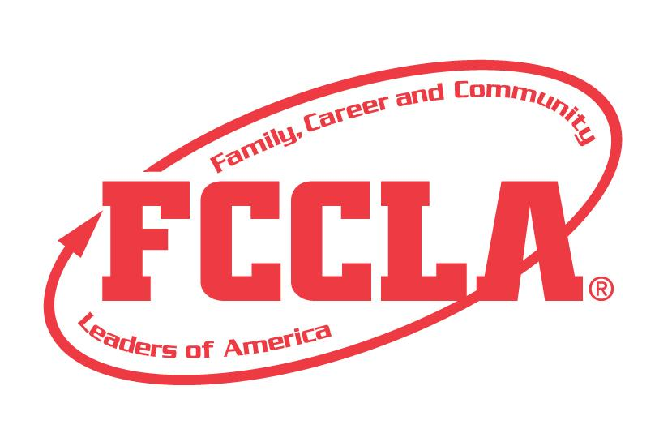

FCCLA IN ACTION

STATE PROJECT
FCCLA members must be affiliated by February 1st

FCCLA IN ACTION

Overview: FCCLA In Action is a project to recognize students and chapters who use the planning process to showcase a specific FCCLA National Program of Family, Career, and Community Leaders of America. Students/Chapters may use one of the following national programs to create their project; Career Connections, Community Service, Families Acting for Community Traffic Safety (FACTS), Families First, Financial Fitness, Stand Up, and Student Body. Students must create a presentation demonstrating their increased knowledge of FCCLA.

Students who complete this state project will receive individual recognition and their chapter will receive chapter recognition with a respective nametag ribbon that corresponds to the national program at the Indiana FCCLA State Conference.

**This project will now be used for state National Program Recognition instead of completing the National Program Application. If you would like National FCCLA Recognition you will need to also complete the online form on the National FCCLA Website.**

Entry: Individual or Team (maximum of 3) Event

VISUAL GUIDELINES:
- Use of the planning process to develop your project and include the planning process summary.
- For this project a Trifold Board or Digital Presentation can be used.
  - Trifold Board: A tri-fold display board (not exceeding 18” deep X 4’ wide X 4’ high, with no use of electrical equipment).
  - Digital Presentation: PowerPoint or Google Slides presentation must be submitted with no more than 30 slides total. Name the file with the student first and last name, chapter name, and state project.

PROJECT DETAILS:
Display Board | Slides Presentation
- The title of the project, FCCLA in Action, must be included on the front of the board and the subtitle of the National Program  - There must be a 3” X 5” index card attached to the lower corner on the back of the display that identifies: Name, Chapter name, School, City, State, Grade and District.  - Each step of the Planning Process is fully explained, neatly typed, no more than 1 page total. Attach the planning process page to display the board on front or back. | - The title of the project, FCCLA in Action, must be included (If digital: Title must be on Slide 1) and the subtitle of the National Program  - A slide identifying: Name, Chapter name, School, City, State, Grade and District.  - Each step of the Planning Process is fully explained, neatly typed, and can be up to five slides total for the Planning Process Summary Form.

- Each part of the planning process must be on individual slides or each part must be on individual pages on the display board in addition to the full planning process that is attached to the back side of the tri-fold board.

- The display or slides must include the following:
  - Identify Concerns: Explain local concerns and how the national program addresses the concerns.
    - How the project Relates to the National Program
    - Review national program selected, its components, and its goal
  - Set a Goal: State what you want to accomplish in concrete and measurable terms
    - Express how the goal relates to national program concerns and to the size and demographic nature of chapter and community to which members belong.
  - Form a Plan: Create a chronological sequence in which the program was accomplished.
    - Determine who, what, when, where, and how to plan the project;
    - List resources needed and gathered. Identify possible barriers; include ways to recognize accomplishments.
  - Act: Demonstrate the “Act” with pictures taken during the project
  - Follow Up: Share methods of publicizing project efforts and recognizing participants.
    - Present methods of evaluating project. Include successes and areas of possible improvement.
  - FCS Coursework/Standards: Describe relationship of project content to Family and Consumer Sciences coursework.

- The project will be evaluated according to the FCCLA in Action rubric.

FCCLA Planning Process
Summary Page Template
(This template may be modified, but all headings must be used in the correct order. The FCCLA logo and Planning Process graphics are encouraged but not required.)

IDENTIFY CONCERNS

SET A GOAL

FORM A PLAN (WHO, WHAT, WHEN, WHERE, HOW, COST, RESOURCES, AND EVALUATION)

ACT

FOLLOW UP

FCCLA IN ACTION: SELF SCORE IS OPTIONAL
National Program:____________________________________________________(PLEASE LIST)
Evaluation |  |  |  | Self-Score | Score
SLIDE PRESENTATION  0 – 10 pts | Does not meet the specifications. Not neat or appealing. More than 2 required elements missing  0-3 | No Title  Missing 1or 2 required elements. Visual appeal could be improved  4-7 | Meets size specification, Title included  Neat and well organized and visually appealing  8-10
FCCLA PLANNING PROCESS  0 – 10pts | Not attached  Not legible  0-3 | Available, but not attached  All steps are summarized  Somewhat messy  4-7 | Planning Process is fully explained, neatly typed or written, and attached  8-10
GRAMMAR  0 – 10 pts | Extensive grammatical and spelling errors  0-3 | Few grammatical and spelling errors  4-7 | No grammatical or spelling errors  8-10
APPEARANCE  0 –10 pts | Display has minimal appeal both in design and content  0-3 | Display needs some improvement in design and content  4-7 | Visually appealing,  creative, and appropriate in design and content  8-10
RELATIONSHIP TO THE NATIONAL PROGRAM  0 – 5 | No concern is identified, or concerns are not clear  0-1 | Concern is identified with lack of explanation or relationship to a National Program  2-3 | Concern is identified with 2 statements of the issue with strong relationship to the National Program  4-5
KNOWLEDGE OF  NATIONAL PROGRAM  0 – 10 | Knowledge of the national program seems limited  0-3 | Some knowledge of national program is apparent  4-7 | Extensive knowledge is explained and applied to project throughout  8-10
SET A GOAL:  STRUCTURE  0 – 5 | Goal is missing or incomplete  0-1 | Goal is stated adequately  2-3 | Goal is stated strongly, ambitious and clear steps are identified, concrete, and measurable  4-5
FORM A PLAN:  ORGANIZATION AND TIMELINE  0 – 10 | Plan is missing or missing logistics and timeline  0-3 | Plan logical and has timeline but more detail is needed  4-7 | Plan is realistic, sequenced and identifies who, what, where, when, why, and how  8-10
FORM A PLAN:  RESOURCES AND PARTNERS USED  0 - 5 | No or limited evidence of resources or partnerships  0-1 | Evidence of resources or partnerships  were explored  2-3 | The project identifies attempts to develop relationships with partners and resources needed  4-5
ACT:  ACTION TAKEN  0 - 10 | No or few pictures are displayed  0-3 | Several pictures are displayed but no explanation  4-7 | Pictures explain most or all aspects of the project  8-10
FOLLOW UP:  EVALUATION  0 - 5 | Evaluation methods are not evident or are limited in the project  0-1 | Evaluation methods are included in the plans and results  2-3 | Evaluation methods are evident, purposefully used. Success and improvements included  4-5
RELATIONSHIP TO FCS COURSEWORK  0 – 10 | No or minimal evidence of relationship with FACS  0-3 | Some evidence of relationship with FACS  4-7 | Knowledge of FACS Coursework is evident and explained well  8-10
 | TOTAL: 100 PTS POSSIBLE (COMMENTS ON BACK)

Name__________________________________________School___________________________________
0-69 | 70-79 | 80-89 | 90-100
Participation | Bronze | Silver | Gold

