INDIANA

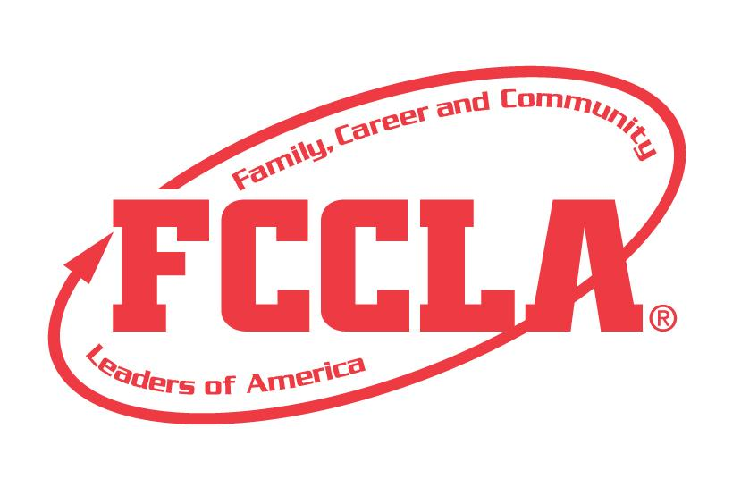

E.C.O.

ENVIRONMENTAL

AND CONSUMER OPTIONS

STATE PROJECT

FCCLA members must be affiliated by February 1st
E.C.O.

Overview: ECO (Environmental and Consumer Options) is a project recognizing student teams who use the planning process to strengthen the community’s understanding of environmental sustainability, popularly known as the “Go Green Movement”. Students must create a portfolio and planning process summary page demonstrating their increased knowledge and public awareness of environmental issues.

Entry: Individual or Team (maximum of 3) Event

PORTFOLIO GUIDELINES:
- For this project a PDF file can be submitted electronically OR a Three Ring Binder can be used.
  - Three Ring Binder: this can be in the official FCCLA red or white three ring binder (can be purchased through the E-Store)
  - PDF File: .For submission, please submit a portfolio as one pdf file. Name the file with the student first and last name, chapter name, and name of the state project.
- A title or title page must be on the front of the portfolio. The title of the project, Environmental and Consumer Options must be included. A subtitle is optional.
- There must be a project identification page (8 ½” X 11”) page in the portfolio identifying:
  - Participant name
  - Participant grade
  - Name of chapter
  - Name of school, school address, city and state
  - District number
- Includes the situation, planning process summary page up to two pages, and final decision
- Up to 20 pages TOTAL

PROJECT DETAILS:
- Each step of the Planning Process is fully explained, neatly typed and in the portfolio.
- The portfolio must include explanations and evidence of the following:
  - brought environmental awareness to the community by . . .
  - benefited the community by . . .
  - benefited the chapter by . . .
  - increased public awareness by…
Some items that may be used, but not limited to:
  - Newspaper Clippings
  - Project Samples
  - Pictures
  - Social Media
- Possible Project Topic Ideas (Projects are not limited to these ideas.)
Recycling | Food Safety | Green Design | Organic Foods
Composting | Food Availability | Global Warming | Redesign

- The project will be evaluated according to the E.C.O. rubric.

FCCLA Planning Process
Summary Page Template
(This template may be modified, but all headings must be used in the correct order. The FCCLA logo and Planning Process graphics are encouraged but not required.)

IDENTIFY CONCERNS

SET A GOAL

FORM A PLAN (WHO, WHAT, WHEN, WHERE, HOW, COST, RESOURCES, AND EVALUATION)

ACT

FOLLOW UP

ECO

Self Scoring is Optional
Evaluation |  |  |  | Self-Score | Score
PORTFOLIO  0-10 pts | Does not meet size specification and missing title and project ID page  0-3 | Does not meet size specification or missing required elements  4-7 | Meets size specification, title and project ID page included  Neat and well organized  8-10
FCCLA PLANNING PROCESS  0 – 15 pts | Not included or not well developed  0-4 | Included but not complete  5-9 | Planning Process is fully explained, neatly typed or written, and included  10-15
GRAMMAR  0 – 10 pts | Extensive grammatical and spelling errors  0-3 | Few grammatical and spelling errors  4-7 | No grammatical or spelling errors  8-10
APPEARANCE  0 – 10 pts | Display has minimal appeal both in design and content  0-3 | Display needs some improvement in design and content  4-7 | Visually appealing,  creative, and appropriate in design and content  8-10
COMMUNITY ENVIRONMENTAL AWARENESS  0 – 15 pts | Explanation or evidence missing or limited  0-4 | Explanation or evidence basic, not detailed  5-9 | Community elderly awareness evident and thorough  10-15
BENEFITTED THE COMMUNITY  0 – 15 pts | Explanation or evidence missing or limited  0-4 | Explanation or evidence basic, not detailed  5-9 | Benefits to the community clear and thorough  10-15
BENEFITTED THE CHAPTER  0 – 15 pts | Explanation or evidence missing or limited  0-4 | Explanation or evidence basic, not detailed  5-9 | Benefits to the chapter clear and thorough  10-15
INCREASED PUBLIC AWARENESS  0 – 10 pts | Explanation or evidence missing or limited  0-3 | Explanation or evidence basic, not detailed  4-7 | Explanation and evidence of increased public awareness clear and thorough  8-10
Total 100 pts possible

COMMENTS:

Name__________________________________________School___________________________________

0-69 | 70-79 | 80-89 | 90-100
Participation | Bronze | Silver | Gold

