INDIANA
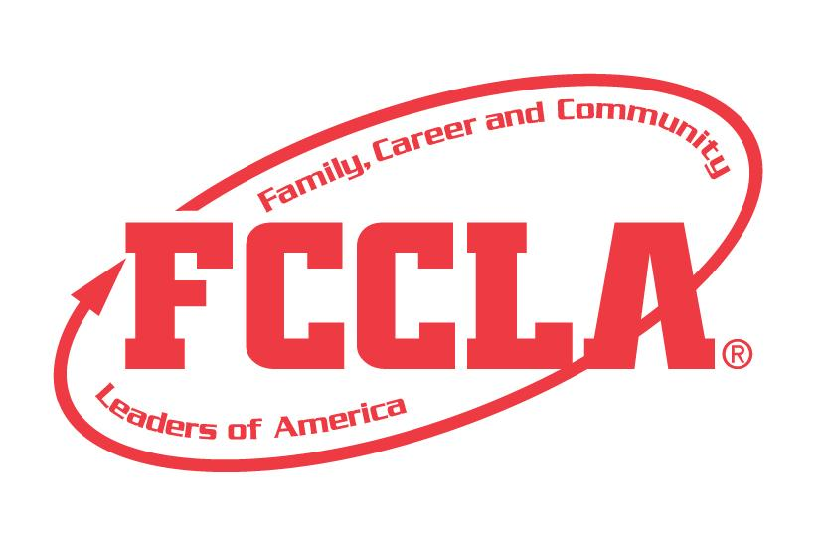

EARLY CHILDHOOD: LEARNING PAC

STATE PROJECT
FCCLA members must be affiliated by February 1st
Early Childhood Learning Pac
Overview: A self-contained unit with lessons to teach young children a developmentally appropriate concept. This will include a sturdy container with lid and a guide that describes each themed activity. This project can be an individual or team event to be displayed at State Leadership Conference.
Entry: Individual or Team (maximum of 3) Event
GUIDELINES:
- Use of the planning process to develop your project and include the planning process summary page.
- A sturdy box depicting the theme to hold the portfolio and activities.
- There must be a 3” x 5” Project Identification Card attached to the cover of the Learning Pac Guide. Includes: Name, Chapter name, School, City, State, Grade and District.
- PORTFOLIO GUIDELINES:
  - A portfolio – 1” to 3” 3-ring binder – will be utilized for the Learning Pac Guide and included in the box.
Project Details:
- A Learning Pac Guide (in a 3-ring binder to be included in the box) includes:
  - The theme, planning process summary form, objectives, identified group and resources used.
  - The title page will include Title of the project, Early Childhood Learning Pac, theme, participant name, grade, chapter name, school name, city, state, and FCCLA district
  - **In the guide, describe each of the activities, how they relate to the objectives, step by step directions, approximate time involved, and all materials needed for each activity. **
- Activities that should be included are:
  - Craft/ Fine Motor
    - Sample of craft/ fine motor activity must be included within the box
    - Include any props/ materials needed within your box
  - Gross Motor
    - Include any props/materials needed within your box (if too large, insert or attach pictures to lesson plan)
  - Music/Circle Time:
    - Words /diagrams of motions must be included on your lesson page
    - Include any links to music used (example: Youtube)
  - Nutritious Snack:
    - Picture of snack must be included
  - Story Time:
    - Story book, flannel board story, puppet story, etc.
    - Book must be included within the box
  - Math OR Science Activity:
    - Sample of activity must be included within the box
  - Computer Generated or Hand Drawn Mock-up of Bulletin Board/Visual:
    - related to theme
    - this could be door decorations
FCCLA Planning Process
Summary Page Template
(This template may be modified, but all headings must be used in the correct order. The FCCLA logo and Planning Process graphics are encouraged but not required.)

IDENTIFY CONCERNS

SET A GOAL

FORM A PLAN (WHO, WHAT, WHEN, WHERE, HOW, COST, RESOURCES, AND EVALUATION)

ACT

FOLLOW UP

Early Childhood Learning Pac

SELF SCORE IS OPTIONAL
EVALUATION |  |  |  | SELF-  SCORE | SCORE
Container  0 – 10 pts | No theme, container is not sturdy or is missing  0-3 | Theme lacks creativity, missing components  4-7 | Meets requirements, sturdy box, depicts theme, set up on time, neat, well organized  8-10
Learning Pac Guide  0 – 15 pts | Contains only 1-2 of required components  0-4 | States theme and objectives but missing other key requirement  5-9 | Contains theme, objectives, summary page, audience age, and resources  10-15
FCCLA Planning Process  0 – 10 pts | Not included or not well developed  0-3 | Included but not complete  4-7 | Planning Process is fully explained, neatly typed or written, and included  8-10
Craft/Fine Motor  0 – 10 pts | Included in guide, lacks creativity, sample included missing items  0-3 | Included in guide and sample included, creative, average work but missing details.  4-7 | Included in guide and sample included; detail; related to objectives; directions given, time, materials included.  8 -10
Gross Motor  0 – 10 pts | Included in guide; lacks creativity, missing items  0-3 | Included in guide; props included, creative, average work but missing details  4-7 | Included with props; detailed; related to objectives; directions given, time, materials included  8-10
Music/Circle Time  0 – 10 pts | Included in guide; lacks creativity, missing items  0-3 | Included in guide; creative, average work but missing details  4-7 | Included; words and diagrams; great detail; related to objectives; directions given, time & materials included.  8-10
Nutritious Snack  0 – 10 pts | Included in guide; lacks creativity, missing items  0-3 | Included with picture, creative, average work but missing details  4-7 | Included with picture; great detail; related to objectives; directions given, time & materials included.  8 -10
Story Time  0 – 10 pts | Included in guide; lacks creativity, Missing book, directions and time commitment  0-3 | Included in guide; creative, average work but missing details  4-7 | Included; great detail related to objectives; directions given. Book appropriate for theme and all items included.  8-10
Math/ Science Activity  0 – 10 pts | Included in guide; lacks creativity, missing book, directions and time commitment  0-3 | Included in guide; creative, average work but missing details  4-7 | Included in guide; described in great detail; related to objectives; directions given, time & materials included.  8-10
Visual  0 – 5 pts | Missing and unrelated to theme  0 -1 | Missing or unrelated to theme  2-3 | Visual included; Creative, age & theme appropriate, high quality work. Neat  4-5
TOTAL 100 pts. Possible (comments on back)

Name_________________________________________School______________________________________
0-69 | 70-79 | 80-89 | 90-100
Participation | Bronze | Silver | Gold

