INDIANA
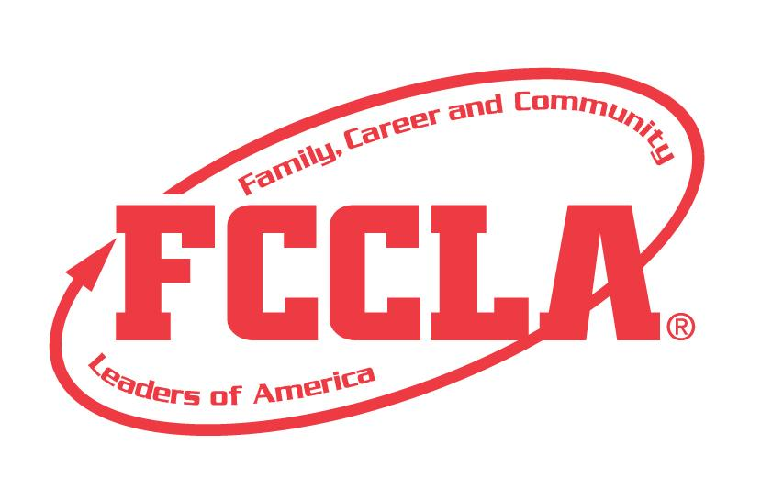

EARLY CHILDHOOD:
HEALTHY SNACK
STATE PROJECT
FCCLA members must be affiliated by February 1st

Early Childhood Healthy Snack Preparation
Overview: Early Childhood Healthy Snack Preparation, an individual event, recognizes participants who demonstrate their ability to guide children through a meaningful activity involving the preparation of a healthy snack. Participants must prepare a portfolio that documents their experience.
Entry: Individual Event
PORTFOLIO GUIDELINES:
- For this project a PDF file can be submitted electronically OR a Three Ring Binder can be used.
  - Three Ring Binder: this can be in the official FCCLA red or white three ring binder (can be purchased through the E-Store)
  - PDF File: For submission, please submit portfolio as one pdf file. Name the file with the student first and last name, chapter name, and name of the state project.
- A “decorative and thematic” title or title page must be on the front of the binder of as the first page of the PDF. The title of the project, Early Childhood Healthy Snack must be included. A subtitle is optional.
- There must be a project identification page (8 ½” X 11”) page in the portfolio identifying:
  - Participant name
  - Participant grade
  - Name of chapter
  - Name of school, school address, city and state
  - District number
- Includes a page with the situation, planning process page and final decision.
- Up to 20 pages TOTAL

PROJECT DETAILS:
- Each step of the Planning Process is fully explained, neatly typed, up to two pages and placed in the portfolio.
- Students MUST present a healthy snack lesson to children, focusing on proper nutrition and sanitation practices.
- The portfolio must include explanations and evidence of the following in no more than 20 pages.
  - Lesson Plan: Participants may re-type on one 8 ½” x 11” page on plain paper using the provided lesson plan format.
  - Evidence of Experience: Show evidence of the participant’s experience in an activity that involves providing young children with a nutritious snack.
  - Effectively Illustrates Content: Show evidence of the participant’s ability to create developmentally appropriate activities and knowledge of young children.
LESSON PLAN FORMAT FOR EC: HEALTHY SNACK EVENT
Name of Participant _____________________________ Date Presented to Children___________________
Name of Project __________________________________________Age of Children ___________________
Purpose of Snack Preparation: ______________________________________________________________
Recipe: List ALL equipment and ingredients
Step by Step Directions:
Closure (how will you prepare the children to move on)
References:

FCCLA Planning Process
Summary Page Template
(This template may be modified, but all headings must be used in the correct order. The FCCLA logo and Planning Process graphics are encouraged but not required.)

IDENTIFY CONCERNS

SET A GOAL

FORM A PLAN (WHO, WHAT, WHEN, WHERE, HOW, COST, RESOURCES, AND EVALUATION)

ACT

FOLLOW UP

Early Childhood: Healthy Snack Preparation
Self Score is Optional
EVALUATION |  |  |  | SELF SCORE | SCORE
PORTFOLIO  0-10 pts | Does not meet size specification and missing title and project ID page  0-3 | Does not meet size specification or missing required elements  4-7 | Meets size specification, title and project ID page included. Neat and well organized  8-10
FCCLA PLANNING PROCESS  0 – 10 pts | Not included or not well developed  0-3 | Included but not complete  4-7 | Planning Process is fully explained, neatly typed or written, and included  8-10
GRAMMAR  0 – 10 pts | Extensive grammatical and spelling errors  0-3 | Few grammatical and spelling errors  4-7 | No grammatical or spelling errors  8-10
Lesson Plan  0 – 15 pts | Missing or incomplete  0-4 | Missing detail of lesson  5-9 | Lesson plan is fully explained and developed  10-15
Recipe  0 – 10 pts | No recipe or only partial ingredients listed  0-3 | Recipe included but does not meet Nutrition Guidelines  4-7 | Neatly typed or written. Meets Nutrition Guidelines  8-10
Safety and Sanitation  0 – 15 pts | No evidence of safety and sanitation  0-4 | Some safety and sanitation practices were demonstrated  5-9 | Safety and Sanitation practices are thoroughly demonstrated  10-15
Evidence of Interaction with Children  0 – 10 pts | No evidence presented  0-3 | Limited evidence of child interaction  4-7 | Thorough evidence of child interaction  8-10
Effectively illustrates Project Content  0 -- 10 pts | Very little documentation of Presentation  0-3 | Missing one or two elements  4-7 | Snack project illustrated fully throughout portfolio  8-10
Developmentally Appropriate Lesson  0 – 10 pts | Lesson is not develop-mentally appropriate  0-3 | Lesson has areas that are developmentally appropriate  4-7 | Lesson demonstrates an understanding of appropriate practices for age indicated  8-10
TOTAL
100 Possible
Comments:

Name__________________________________________School__________________________________________
0-69 | 70-79 | 80-89 | 90-100
Participation | Bronze | Silver | Gold

