


Dish Requirements Information
Deadline – February 17, 2017

**To be completed for Culinary Competition Team Members ONLY**

Refer to the Culinary Competition guidelines, which outline the rules and requirements for the competition.

Please complete the online google form all dish requirements and all other required team registration information by Friday, February 17, 2017!

https://goo.gl/forms/PbiSUPmV9B1kPN073

If you have two culinary teams, please submit a separate dish order form for each team. Do NOT submit orders for both teams on the same form.

If you have special needs or issues with the form, please e-mail your requests to Alyson McIntyre-Reiger at amreiger@doe.in.gov.

You will receive a confirmation via E-mail by February 22. If you do not receive a confirmation, this means that your dish order was not received. Please follow up if necessary.

Dish Requirements:

On the Dish Order Form, indicate the dishes you will need for each portion of your meal for the competition by writing the description (name and size) of the pieces you need in the left column and the number of pieces you need in the right column. PLEASE use the description names on the following chart. Keep in mind, as outlined in the rules, the starter needs to be on one dish/plate, the starch, protein and vegetable need to be on the second dish/plate, and dessert on a third dish/plate. The following are the dish dimensions/specifications from the event center (these are basic dinnerware dimensions; any size dish may be used for any of the courses). Dish availability will be confirmed with your order confirmation. Dish Orders received after February 18 will be filled on a first come, first served basis and you will be informed if the style you ordered is not available.

Dish Name | Size | Photo
White Dinner Plate | 9 3/4" | 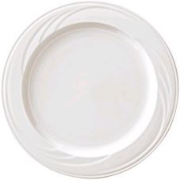
Salad Plate | 6" | 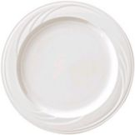
Saucer | 5.75” | 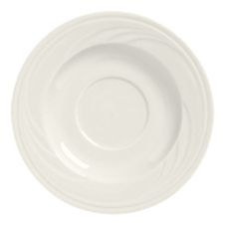
White Bowl | 10 oz  6.5“ diameter  2“ high | 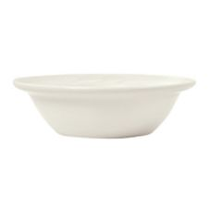
Bouillon Cup | 7 oz  4” diameter  2 1/8” high | 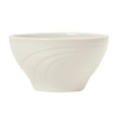
Glass Name | Size | Photo
Water Glass | 10.5 oz | 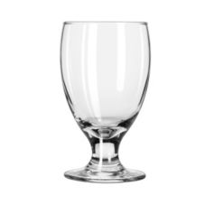

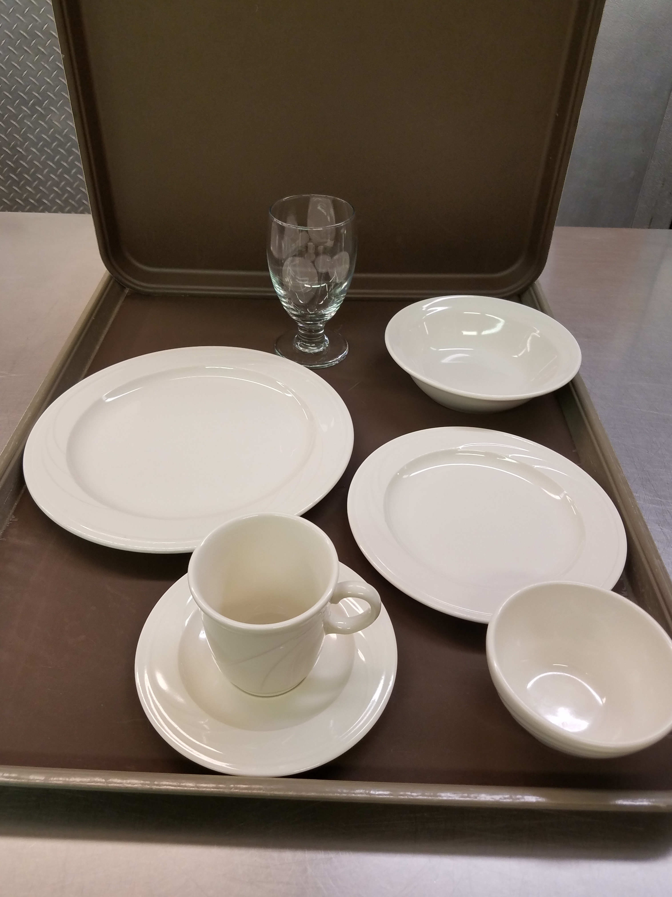

Overview of all dishes and glassware

