STAR Events to Use in All Courses
STAR Events Quiz: https://www.surveymonkey.com/r/KDSWGBT
Career Investigation ▪ Chapter in Review Display or Portfolio ▪ Chapter Service Project Display or Portfolio ▪ Entrepreneurship ▪ Interpersonal Communications ▪ Job Interview ▪ Leadership ▪ National Programs in Action ▪ Parliamentary Procedure ▪ Professional Presentation▪
Promote and Publicize FCCLA ▪ Public Policy Advocate

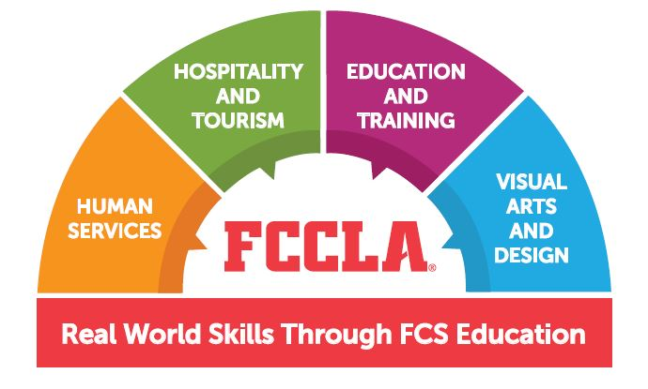
STAR Events Related to Specific Pathways
Hospitality and Tourism  Baking and Pastry  Culinary Arts  Culinary Math Management  Event Management  Food Innovations  Hospitality, Tourism and Recreation  Nutrition and Wellness  Say Yes to FCS  Sports Nutrition  Sustainability Challenge | Education and Training  Early Childhood Education  Focus on Children  Public Policy Advocate  Say Yes to FCS Education  Teach and Train  Virtual-Digital Stories for Change  Virtual-Instruction Video Design
Human Services  Early Childhood Education  Event Management  Focus on Children  Interpersonal Communications  National Programs in Action  Nutrition and Wellness  Public Policy Advocate  Say Yes to FCS  Sustainability Challenge | Visual Arts and Design  Fashion Construction  Fashion Design  Interior Design  Professional Presentation  Repurpose and Redesign  Say Yes to FCS  Sustainability Challenge  Virtual – Chapter Website  Virtual-Instruction Video Design

State Projects to Use in All Courses
Beyond the Basics ▪ Career Exploration ▪ Focus on the Basics ▪ SMILE

State Projects Related to Specific Pathways
Hospitality and Tourism  Early Childhood Healthy Snack  ECO  FCCLA in Action  Food Marketing | Education and Training  Early Childhood Healthy Snack  Early Childhood Learning Pac  FCCLA in Action  Healthy Choices=Healthy Teens  Recruit
Human Services  Early Childhood Learning Pac  ECO  FCCLA in Action  Healthy Choices=Healthy Teens  SMILE | Visual Arts and Design  ECO  Trend Board

