INDIANA
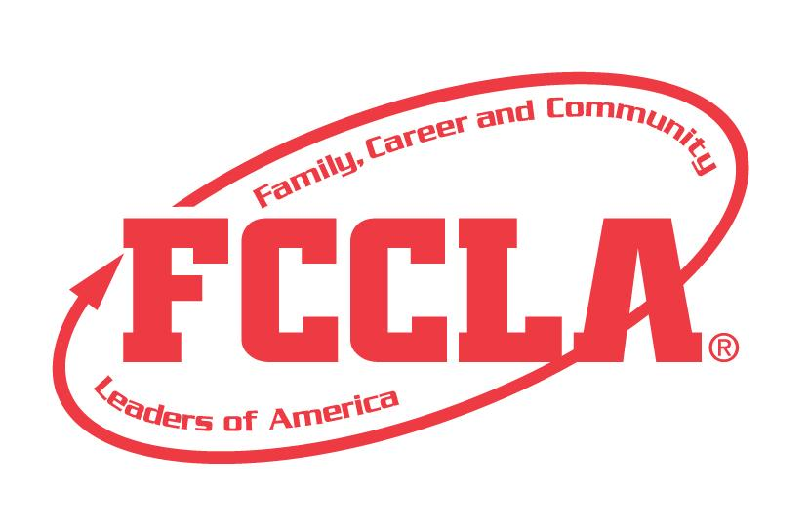
HEALTHY CHOICES =
HEALTHY TEENS

STATE PROJECT
FCCLA members must be affiliated by February 1st

HEALTHY CHOICES = HEALTHY TEENS

OVERVIEW: Healthy Choices = Healthy Teens is a project to recognize students who use the planning process to understand the consequences of choices. Students must create a portfolio that demonstrates their increased knowledge of the planning process and decision-making skills.

Entry: Individual
PORTFOLIO GUIDELINES:
- For this project a Digital Presentation OR Three Ring Binder Portfolio can be used.
  - Three Ring Binder Portfolio: this can be in the official FCCLA red or white three ring binder (can be purchased through the E-Store)
  - Digital Portfolio: Name the file with the student first and last name, chapter name, and state project. For submission, please submit portfolio as one pdf file.
- A title or title page must be on the front of the portfolio. The title of the project, Healthy Choices=Healthy Teens must be included. A subtitle is optional.
- There must be a project identification page (8 ½” X 11”) page in the portfolio identifying:
  - Participant name
  - Participant grade
  - Name of chapter
  - Name of school, including city and state
  - District number
- Includes the situation, planning process summary pages up to 2 pages, and final decision
- Up to 20 pages TOTAL

PROJECT DETAILS:
- Using the student handout, pick or create a situation to resolve
- Complete the student handout
- Create a portfolio that depicts the situation, planning process, and final decision
- The project will be evaluated according to the Healthy Choices=Healthy Teens rubric

Healthy Choices = Healthy Teens
Student Handout
Name _____________________________________Chapter____________________

1. Pick OR create a situation.
- You are at a party with some friends who are drinking. You know that if you do decide to drink that you will be able to stay at your friends’ house but you will have to answer to your parents.
- While riding to school with friends, the driver decides he wants to see how fast his car can go. You know it is unsafe but if you say anything, they might make fun of you.
- You are hanging out with some friends, trying to decide what to do. One friend suggests going to a local hangout place. You want to go but you know your parents wouldn’t let you because it is in an unsafe part of town.
- You are on-line and notice a student from your school is cyber-bullying another student from your school. The bullying is escalating and you fear it will get out of hand. Your school has an anti-bullying policy. What do you do?
- One of your teammates is showing signs of an eating disorder. Her mother and your mother are friends. If you tell your mother, she will definitely say something to your teammates’ mothers. What should/do you do?
- You notice your best friend, who is dating, is receiving a lot of text messages from her boyfriend/girlfriend and your friend is becoming very withdrawn from your friendship relationship. The boyfriend/girlfriend is controlling all of your friend’s free time. You begin to think she/he is in an unhealthy relationship. As a friend, explore the information about unhealthy dating relationships to share with her /him and what your friend should do to help her/him through this situation.
- Create a situation of your own:

2. Using the situation you choose, complete the FCCLA planning process.

FCCLA Planning Process
Summary Page Template
(This template may be modified, but all headings must be used in the correct order. The FCCLA logo and
Planning Process graphics are encouraged but not required.)

IDENTIFY CONCERNS

SET A GOAL

FORM A PLAN (WHO, WHAT, WHEN, WHERE, HOW, COST, RESOURCES, AND EVALUATION)

ACT

FOLLOW UP

Healthy Choices = Healthy Teens
Self Score is Optional
EVALUATION |  |  |  | SELF  SCORE | SCORE
Portfolio  0 – 10 pts | Does not meet size specification and missing title and project ID page  0-3 | Does not meet size specification title or project ID page missing or incomplete, not organized  4-7 | Meets size specification, title and project ID page included, neat, well organized  8-10
Grammar  0 – 10 pts | Extensive grammatical and spelling errors  0-3 | Some grammatical and spelling errors  4-7 | Few or no grammatical or spelling errors  8-10
Appearance  0 – 5 pts | Portfolio has minimal appeal both content and design  0-1 | Portfolio needs some improvement in content and design  2-3 | Creative, appropriate, high-quality word, color, and design choices  4-5
Identify Concerns  0 – 15 pts | Missing or incomplete  0-4 | Incomplete  Not well thought out  5-9 | Thorough, well-developed, neat  10-15
Set a Goal  0 – 15 pts | Missing or incomplete  0-4 | Incomplete  Not well thought out  5-9 | Thorough, well-developed, neat  10-15
Form a Plan  0 – 15 pts | Missing or incomplete  0-4 | Incomplete  Not well thought out  5-9 | Thorough, well-developed, neat  10-15
Act  0 – 15 pts | Missing or incomplete  0-4 | Incomplete  Not well thought out  5-9 | Thorough, well-developed, neat  10-15
Follow Up  0 – 15 pts | Missing or incomplete  0-4 | Incomplete  Not well thought out  5-9 | Thorough, well-developed, neat  10-15
TOTAL 100 POSSIBLE

COMMENTS:

Name_________________________________________School_________________________________

0-69 | 70-79 | 80-89 | 90-100
Participation | Bronze | Silver | Gold

