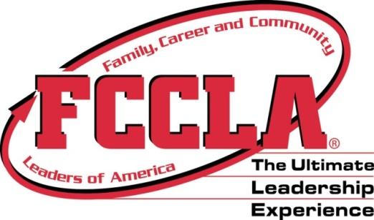
State Farm Celebrate My Drive Grant Form
Chapter Name
School Name
Adviser Name Adviser Email
Address Phone Number
State Farm Agent Name & Contact Information
Name Phone Email
Description Of Celebrate My Drive Activity (date, # of members participating, activities, etc)

Estimated Budget for Supplies:
Supplies needed to complete activity | Budget $ amount

Incentives:
- $150.00 check written to affiliated chapters for supplies
- TWO (2) FREE registrations (can be for chapter adviser or chapter member) for State Leadership Conference March 8-10, 2015 and State project must be entered for judging.
LIMITED to 1st 25 chapters to complete and email the form to Leslie Gackle. After that, remaining resources will be looked into to fund additional chapter projects.
Due: October 1, 2015 to Leslie Gackle at lgackle@hotmail.com

